**IEEE CS Bangalore Chapter Internship and Mentorship Program - 2025**

**Duration: 1st April 2025 to 30th September 2025**

**Monthly Progress Report Template**

**Project ID: P18**

**Name of the Students: Srushti E N**

**Deeksha S M**

**Dakshitha Pathipati**

**Lokesh R M**

**University/ College Name: GITAM University, Bengaluru Campus.**

**Name of the Mentor: Dr. N Gayathri (M29)**

**Mentor’s Organization: GITAM University, Bengaluru Campus.**

**Title of the Project: Digital Phenotyping for Early Detection of Student**

**Stress**

Contents

1. Problem Definition 3

2. Literature Review 3

Digital Phenotyping & Stress Detection 3

Mobile Sensing Modalities 4

Ethical and Privacy Considerations 4

3. Existing System 4

Strengths and Gaps 5

4. Proposed System 5

Hybrid Data Collection Approach 6

Real-Time Stress Inference 6

Technology Stack and Integration 6

5. Knowledge gained - Tools, Technology, Courses etc. 7

6. Architectural Framework 7

Mobile Frontend (Flutter App): 8

Data Ingestion and Storage: 8

Feature Extraction and Backend Processing: 8

Stress Inference Engine: 8

User Feedback and Intervention: 8

7. Project Implementation 9

8. Results 10

9. Conclusion and Future Work 10

10. Research article preparation 11

Citation 11

Digital Phenotyping for Early Detection of Student Stress

Monthly Report – April

# Problem Definition

Student stress and mental health challenges are widespread. Surveys indicate that up to 75% of college students report feeling overwhelmed by stress, with one in five experiencing stress-related suicidal thoughts. Chronic academic and family stress can lead to depression and significantly impair learning outcomes. If left unaddressed, persistent stress can escalate into serious mental health issues and a decline in academic performance.

Early identification of rising stress levels is therefore critical. Digital phenotyping offers a novel approach: it continuously collects data from personal devices, such as smartphones, to quantify behavior and mood. By passively sensing indicators like sleep patterns, mobility, and social activity, a digital phenotyping system can detect subtle changes before students become critically distressed.

Since nearly all young adults—approximately 96% of individuals aged 18 to 29—own smartphones, mobile sensing is a highly feasible method. Using smartphones to monitor behavioral patterns provides a scalable way to flag early signs of stress. This proactive monitoring could enable timely support or interventions, potentially reducing the negative impact of stress on student well-being and academic performance.

# Literature Review

## Digital Phenotyping & Stress Detection

Digital phenotyping is defined as the “moment-by-moment quantification of the individual-level human phenotype in situ using data from personal digital devices.” In mental health research, smartphone-based sensing has been used to infer stress, anxiety, and depression from behavioral markers.

For instance, a systematic review found that passive smartphone sensors—such as GPS, accelerometer, and microphone—can reveal meaningful patterns. Stressed individuals often visit fewer places, show reduced physical activity, have irregular sleep patterns, and spend more time on their phones. Many of these studies use machine learning to correlate sensor-derived features like mobility trajectories, speech characteristics, and sleep duration with standardized stress and mood assessments.

Overall, evidence shows that mobile sensing is effective at detecting behavioral signatures of stress and mild depression.

## Mobile Sensing Modalities

Research supports a hybrid data collection approach. Active data—such as self-reported surveys or Ecological Momentary Assessments (EMAs)—captures subjective emotional states, while passive data—automatically logged by sensors—records objective behaviors.

Combining both types of data typically leads to more accurate stress detection. For example, a student might receive occasional prompts to rate their stress levels while their phone continues to log location, physical activity, and screen usage in the background. Wearable devices like smartwatches and fitness bands can add physiological signals such as heart rate variability and skin conductance, providing even more detailed stress indicators. These multi-modal data streams allow for rich and precise feature extraction.

## Ethical and Privacy Considerations

Digital phenotyping comes with significant ethical challenges. Since it involves the collection of sensitive personal data—including location, communication patterns, and health information—strong privacy protections are necessary.

Best practices include transparency, informed consent, secure data storage, and clear accountability. Apps targeting student stress must anonymize or encrypt data and give users the ability to opt in or out of each sensor stream. Developers also need to avoid algorithmic bias and clearly explain how predictions are generated. Ethical handling of data is not optional—it is essential and must align with mobile health research guidelines and institutional review standards.

# Existing System

Several systems have explored mobile-based stress monitoring, especially in student populations.

On the research front, ***Dartmouth’s StudentLife*** project was one of the earliest efforts to use smartphones to monitor student behavior and stress. Over a 10-week academic term, the app automatically tracked participants’ sleep, physical activity, conversations, and location (e.g., time spent in class or dorm), alongside self-reported stress levels. Analysis of this data revealed how academic workload influences students’ mood and health over the semester.

Another example is the ***Vibe Up*** app from Australia, which gathered passive sensor data—including accelerometer, gyroscope, and step count—from around 400 students, alongside stress surveys. Using machine learning, Vibe Up was able to classify users' stress severity, showing that passive sensing alone could effectively identify high-stress individuals.

In contrast, many commercial wellness apps prioritize user reflection and relaxation over stress prediction. Mood-tracking apps like ***T2 Mood Tracker*** and ***Daylio*** rely on voluntary self-reports, while meditation apps such as ***Calm*** and ***Headspace*** offer relaxation exercises without continuous monitoring. Some wearable platforms like ***Samsung Health*** and ***Fitbit*** provide instant stress scores based on heart rate or breathing patterns, but they generally lack predictive, long-term models.

A standout research platform is ***mindLAMP***, an open-source system designed for psychiatric research. It integrates both active data (user surveys) and passive sensor streams. Its modular design—featuring a mobile app, cloud-based data center, and analytics engine—demonstrates how digital phenotyping can be harnessed for clinical and research applications.

## Strengths and Gaps

These systems show that mobile stress sensing is feasible and potentially powerful. However, several challenges remain:

* Research prototypes often require high user engagement and dedicated study devices, which limits scalability in real-world settings.
* Commercial apps generally do not integrate passive data collection, so real-time stress prediction is rare.
* Most systems are designed for short-term studies, with limited tools for long-term, semester-wide monitoring.
* Few platforms provide user-friendly feedback—many focus on data collection but offer no actionable alerts or personalized coping suggestions.

Current solutions highlight both the promise and limitations of mobile stress monitoring. To be truly effective, future systems must integrate passive and active data streams, scale across real-world use cases, and prioritize privacy, user engagement, and actionable feedback.

# Proposed System

Our proposed solution is a cross-platform mobile application developed using Flutter, designed to continuously assess and respond to student stress. The primary goals are to collect both passive and active data streams and to provide early warnings when stress levels rise.

Using Flutter allows us to maintain a single codebase for both Android and iOS, ensuring broad accessibility. Firebase will serve as the backend infrastructure, enabling secure cloud storage, real-time synchronization, and scalable data processing.

## Hybrid Data Collection Approach

The app will gather a combination of passive and active data:

* Passive data includes location (GPS), accelerometer readings (to track physical activity and mobility), screen time and app usage, ambient sound levels (to infer social context), and—when available—vital health data from wearables via Apple HealthKit or Google Fit.
* Active data involves periodic prompts for brief mood or stress surveys, allowing users to self-report emotional states.

A core innovation is the hybrid sensing pipeline. Background data ingestion modules will collect sensor streams continuously. Simultaneously, user inputs and contextual information such as calendar events and academic deadlines will be logged. All inputs will be timestamped and stored securely in Firebase.

## Real-Time Stress Inference

Once collected, the data is processed in the backend where feature extraction is performed. This includes metrics like:

* Daily distance traveled
* Sleep estimation based on phone inactivity
* Communication and usage patterns

These features are fed into a machine learning model trained to infer stress levels in real time. If elevated stress is detected, the app can issue personalized notifications—either alerting the student directly or optionally informing a counselor. Recommendations for coping strategies (e.g. mindfulness exercises, breaks, support resources) can also be provided.

## Technology Stack and Integration

* Flutter provides access to device sensors and builds a responsive, user-friendly interface.
* Firebase offers Authentication, Firestore for database management, and Cloud Functions for scalable processing.
* HealthKit (iOS) and Google Fit (Android) will be used to import health metrics like heart rate variability.

This system leverages the full power of digital phenotyping by blending self-reporting with ambient data collection to create a rich, context-aware stress monitoring tool. The app is designed to run unobtrusively in the background, continuously logging relevant data and offering personalized insights. Ultimately, it aims to help students better understand and manage their stress, supporting both their well-being and academic success.

# Knowledge gained - Tools, Technology, Courses etc.

Throughout this project, we have acquired familiarity with key tools and concepts:

**Flutter and Dart:** An open-source UI toolkit for building natively compiled applications from a single codebase. We learned Flutter fundamentals for crafting cross-platform interfaces and using packages for sensors and state management.

**Firebase Platform:** Google’s mobile/web app development platform that offers real-time databases, user authentication, and cloud functions for scalable backends. We studied Firestore for data storage and Cloud Messaging for notifications.

**Mobile Sensing APIs:** Integration of device capabilities via packages (e.g. sensors_plus for accelerometer/GPS, flutter_health/google_fit) and handling permissions. We also explored HealthKit (Apple) and Google Fit to incorporate step counts and heart rate data.

**Machine Learning & Analytics:** Coursework in machine learning (Coursera/edX) has helped us plan how to preprocess sensor data and train models (e.g. classification) for stress inference. We reviewed libraries like TensorFlow Lite for on-device inference.

**Digital Phenotyping Literature:** We studied academic sources on digital phenotyping, stress detection algorithms, and ethics in digital health. Online courses on data privacy and ethical AI informed our approach to responsible data handling.

**Concepts:** Key learned concepts include ecological momentary assessment (EMA), feature extraction from time-series data, and the importance of balancing user engagement with passive data collection.

Additionally, tutorials and community examples (e.g. sample Flutter sensor apps, Firebase documentation) have guided our architecture design. By combining these skills—cross-platform mobile development, cloud services, mobile health sensing, and ML—we are well-prepared to implement the proposed digital phenotyping solution.

# Architectural Framework

Our system architecture comprises several layers:

## Mobile Frontend (Flutter App):

The user-facing component running on the student’s phone. It handles UI screens (login, stress survey prompts, dashboard), and continuously collects sensor data. Key modules include a Sensor Manager (capturing accelerometer, GPS, microphone levels, etc.) and an EMA Scheduler (triggering user surveys at set intervals). This frontend communicates with the cloud backend over secure HTTPS/Firebase channels.

## Data Ingestion and Storage:

Collected data are uploaded to Firebase. We use Firestore (NoSQL) to store raw sensor streams and user responses. Authentication ensures only authorized access. Firebase’s real-time syncing allows low-latency data flow for near-real-time analysis.

## Feature Extraction and Backend Processing:

A cloud component retrieves raw data (using Firebase Functions or a backend server) to compute meaningful features. For example, a nightly job might aggregate the day’s step count, compute sleep duration from phone inactivity, or tally hours spent in study locations. These features are stored in a processed dataset.

## Stress Inference Engine:

The core analytical module applies a machine learning model (e.g. a trained classifier) to the feature set to predict current stress level. This could run on a cloud server (using Python/TensorFlow) or on-device for privacy. The model leverages patterns identified in the literature (e.g. reduced mobility or increased late-night phone use as stress indicators).

## User Feedback and Intervention:

Predicted stress levels feed into the app’s UI. If stress crosses a threshold, the app may generate notifications, display coping resources, or connect the student to campus counseling. All components are illustrated in the simplified architecture below:

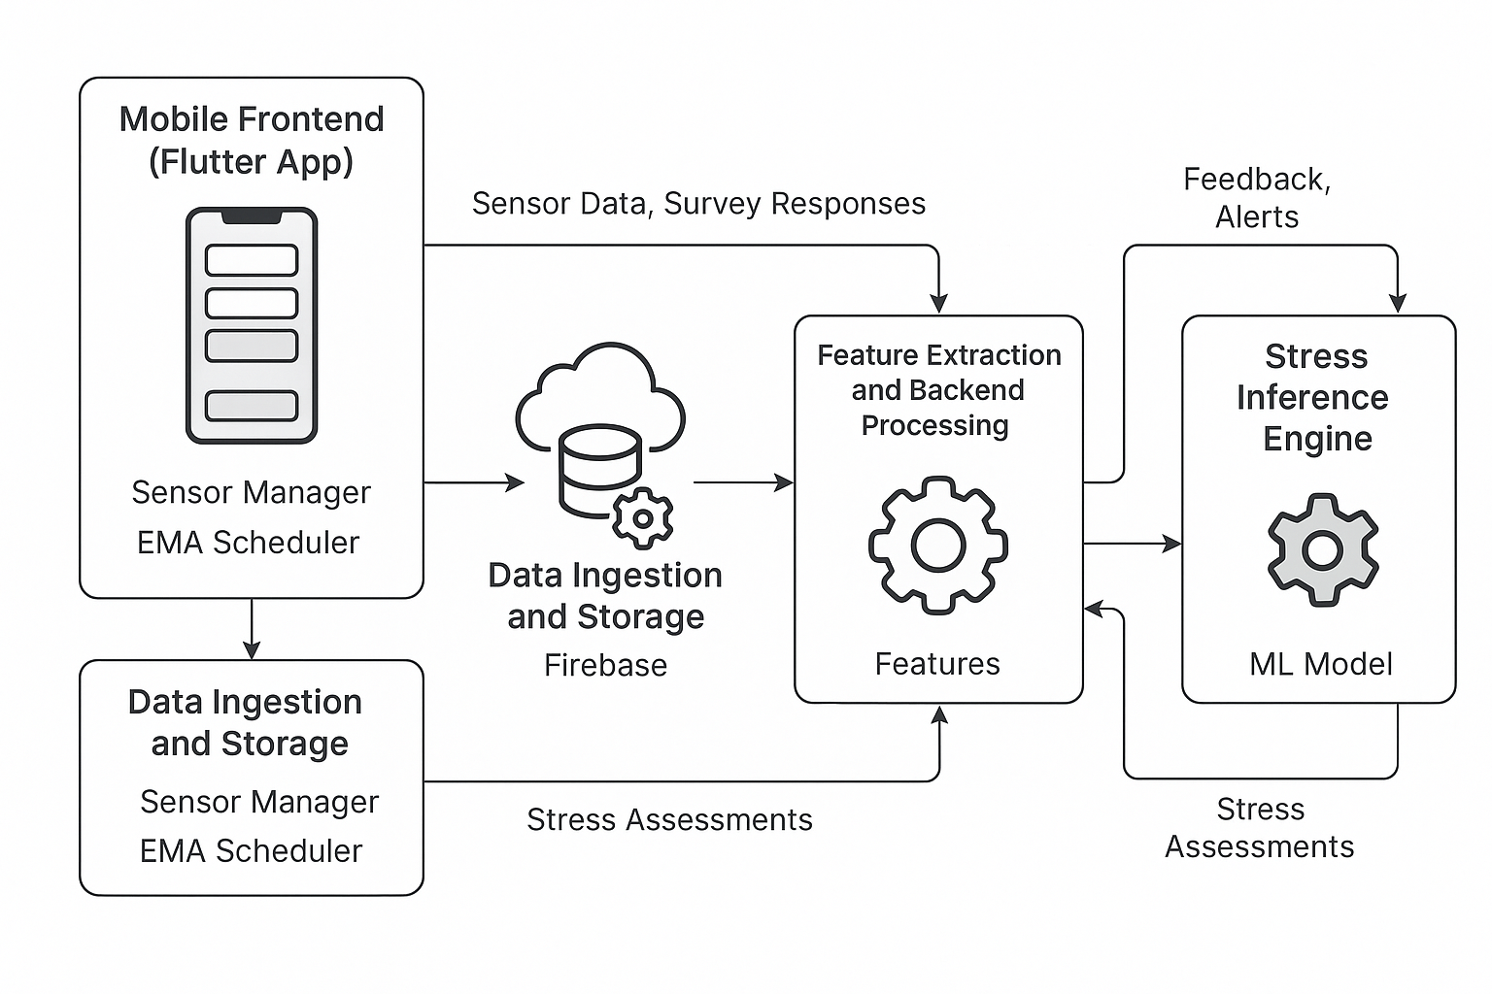

Although not shown here, the architecture includes the mobile app, cloud database (Firebase), data processing pipelines, and ML inference module. Sensors feed into the app, which sends data to the cloud; the backend processes features and returns stress assessments to the app.

In this framework, data flows seamlessly from ***sensors → mobile app → cloud storage → feature processing → stress model → app feedback***. Security and privacy controls (data encryption in transit and at rest, user consent checks) are integrated at each stage. By structuring the system in modular layers (data ingestion, processing, inference, and UI), we ensure scalability and maintainability.

# Project Implementation

At present, we have begun prototyping the system. The Flutter project’s basic UI scaffolding is in place: key screens (user login, consent form, dashboard) have been implemented. Firebase services have been configured, including user authentication and a Firestore database schema for storing sensor and survey data.

We have integrated Flutter plugins to access device sensors—for example, the geolocator plugin to capture GPS coordinates and sensors_plus for accelerometer/gyroscope readings. Concurrently, we designed the overall data flow. Using mock data, we tested uploading to Firestore and retrieving it for analysis. We created initial Dart classes to represent data entities (e.g. SensorRecord, SurveyResponse) and set up listeners to stream data to the backend.

The architecture design (as above) has been validated by setting up Firebase Cloud Functions stubs that can process incoming data. Finally, preliminary experiments confirm our setup works: the app successfully logs user location and motion data to Firebase and reads/writes from the database.

We also drafted the machine learning pipeline in Python: feature extraction scripts can parse timestamped logs, and a simple stress classification model (using a linear SVM) is being trained on synthetic data to test connectivity.

The core infrastructure is operational, enabling us to move forward with refining features and analytics.

# Results

Initial tests demonstrate successful integration of the main components. We have verified that the Flutter app can connect to Firebase, authenticate users, and store sensor data in the cloud. For example, accelerometer readings and GPS samples were recorded in Firestore with correct timestamps. UI modules for login and data display are functional, and the app responds to lifecycle events (pausing/resuming sensing correctly).

On the sensor side, motion and location services are active: we have confirmed that step counts and location changes are logged when the device moves. Screen time and app usage data are also being captured. We tested a simple feature extraction routine (e.g. counting total steps per hour) on the ingested data, which produced expected values.

Although a finalized stress prediction model is still in development, our early machine learning experiments show promise: using a small synthetic dataset, a prototype classifier was able to distinguish “low” vs. “high” stress patterns based on mobility features. Importantly, the end-to-end data pipeline works: data flows from the phone into the database, is processed by our scripts, and the results (stress scores) can be fed back to the app for visualization. These results confirm that the planned system components are viable and correctly interconnected.

# Conclusion and Future Work

In this research/design phase, we have defined a mobile-based framework for early stress detection in students and built the foundational software infrastructure. The cross-platform app (Flutter) and Firebase backend are operational, and basic sensor-data collection and storage have been demonstrated. Our architectural design aligns with best practices in digital phenotyping, combining passive sensing and user input to capture student behavior comprehensively.

Next steps include developing and validating the stress inference models. We will collect pilot data from volunteer students to label stress levels and train more robust classifiers. The UI will be refined to improve user engagement, and we will implement security measures (data encryption, GDPR-compliant consent). We also plan extensive testing of battery impact and data accuracy under real-world conditions. In the longer term, we aim to incorporate advanced features such as anomaly detection (flagging unusual behavior) and personalized intervention suggestions. Eventually, we hope to conduct a pilot study to measure how well the system predicts stress and whether it can meaningfully prompt students to seek help or adopt coping strategies.

# Research article preparation

We intend to publish our findings in an academic venue. A manuscript will be prepared outlining the research goals, methodology, and initial results. The paper will include sections on background (student stress and digital phenotyping), system design (architecture and data collection methods), and evaluation (preliminary accuracy of stress detection). We will follow standard reporting guidelines (e.g. CONSORT for any pilot trials, or PRISMA if we include review elements – ***later on if required for advanced research***) and cite relevant literature.

# Citation

* ***Android Developers - Request location permissions*** *Source: developer.android.com*
* ***Android Developers - Privacy changes in Android 10*** *Source: developer.android.com*
* ***Dartmouth College - Trends in Student Mobility*** *Source: studentlife.cs.dartmouth.edu*
* ***Frontiers in Psychology - Wearable, Environmental, and Smartphone-Based Passive Sensing for Mental Health Monitoring*** *Source: frontiersin.org*
* ***National Library of Medicine - Digital Phenotyping for Stress, Anxiety, and Mild Depression*** *Source: pmc.ncbi.nlm.nih.gov*
* ***Apple Developer Forums - Individual App Usage Using Screen Time API*** *Source: forums.developer.apple.com*
* ***DroidCon - Accessing App Usage History in Android*** *Source: droidcon.com*
* ***Dartmouth College - StudentLife Study*** *Source: studentlife.cs.dartmouth.edu*
* ***National Library of Medicine - Family and Academic Stress and Their Impact on Students' Depression Level and Academic Performance*** *Source: pmc.ncbi.nlm.nih.gov*
* ***Nature - Data Mining for Health: Ethical Territory of Digital Phenotyping*** *Source: nature.com*
* ***GitHub - Flutter*** *Source: github.com*
* ***Firebase - Google's Mobile and Web App Development Platform*** *Source: firebase.google.com*
* ***Frontiers in Psychology - Passive Sensing Data Predicts Stress in University Students*** *Source: frontiersin.org*
* ***National Library of Medicine - Ecological Momentary Assessment Using Smartphone-Based Mobile Application for Affect and Stress Assessment*** *Source: pmc.ncbi.nlm.nih.gov*